Database Mangement System

# Introduction:

In the fast-paced digital environment where everything changes daily and new developments replace historical developments. Like analyzing the historical records of storing the datasets, in previous times the data was stored as a bunch of files and called the file management system. Humans physically store all the data by themselves in files or registers, and in this storing and handling of data human error arises and creates a lot of problems related to storing data. Here is an example of any company, the company uses a file management system, and all the files of the company are stored in a place and suddenly this company wants to use their stored data. So in this scenario, they had to search all the data physically and it took a lot of their precious time maybe there were so many mistakes they made in searching or updating the old records.

To overcome this problem database management systems were introduced, these database management systems handle all the records and provide a simplicity in which everyone can easily search their records and can use previous records as well. These database systems replaced file management systems, and now every organization prefers these systems, these systems also provide security to the data and save all the data and this is the most important key aspect which everyone demands that their data become safe.

For this assessment, there is the task to develop a database, and working on that database the topic chosen for this is the small online savings bank. This bank provides various functionalities to their customers and all of the important things about this database are defined in the report. After reading this report the reader will understand the importance of databases and also can understand how databases will work in the banking or finance field.

# Requirement Specification:

As this report discussed the chosen topic for this database development is a small online savings bank. So in this requirement phase, there is define all the requirements that this database provides to its users help to handle the data moreover enhance the accuracy, and maintain the integrity of the data (*Ogli, R.A.R., 2022*). The main purpose of this database is to provide functionality including managing customers' accounts, managing daily transaction records, and various banking functionalities as well. The database system handles customer information, banking details, etc.

## Database System Requirements:

There are several system requirements that this bank provides to its customers all the requirements are defined as below.

### Customer management:

Store and handle all the customer details and save all the information of the customer which is beneficial for the bank this information includes the customer’s personal information and contact details.

### Account Management:

Banks handle various types of accounts such as savings accounts, current accounts, checking, and fixed accounts. Managing these accounts also ensures checking the balance and the status of the account as well.

### Transaction Management:

The system will store all the information about the daily transactions and it is very important to maintain this information so that no issue will arise regarding this transaction. The bank will record all transactions, these transactions include deposits, withdrawals, transfers, and payment of the bills.

### Loan Management:

The system will also handle all the loan management activities including managing loan details, amount, interest rate, and the repayment schedule so it is good for bank management to hold this information.

### Branch Management:

The database will also store all the information of the branches of the banks and handle all the data of the branches and store the information. The information including the customer details and their account details are stored in a database.

### Employee Management:

The database will also store the information of all the employees who are serving their services to the bank all of the information related to the employees are stored in the database. This information includes their record details, their roles, and the branch assignments.

### Audit and reporting:

Generate reports on customer’s account details and maintain the information on their transactions, loans, and overall working performance of the branches of the bank.

### Security and Integrity:

This is one of the main parts of this system security for every work whether it is related to any field one thing is common security. The security is important to get the satisfaction and win the trust of the customers. So this database management system ensures security and integrity by using appropriate constraints and normalization.

# Entity Relation Diagram:

The entity relation diagram is the main part of database development, the entity relation diagram helps to find out the database entities and their attributes and also identifies their relation with each other (*Azzahra, Z.F. and Anggoro, A.D., 2022*). The entity relation diagram shows the overall working of the database management system. With the help of this diagram, the reader will easily understand the workflow of the data and this diagram helps to make everything easy and understandable all the development of the database is based on this diagram.

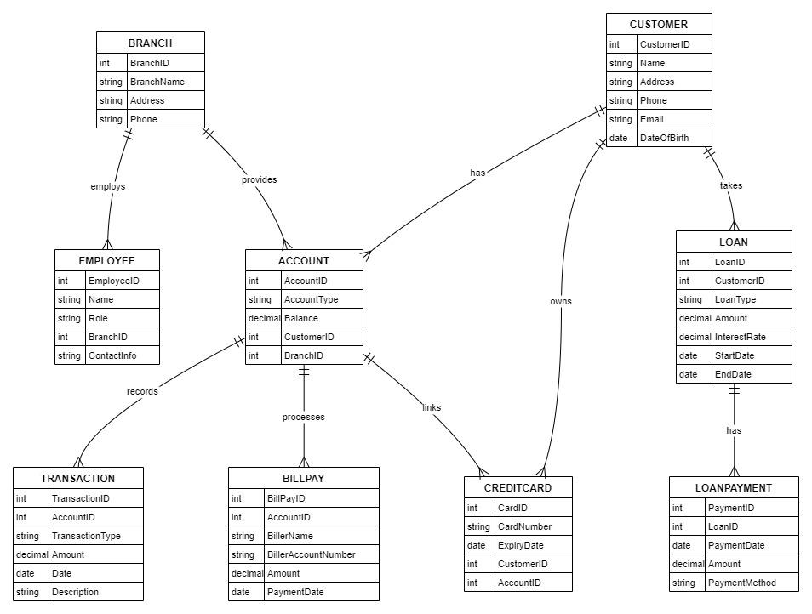

This entity relation diagram consists of 9 tables including Branch, employee, account, transaction, bill pay, credit card, customer, loan, and loan payment. With the table, the attributes of the tables will also be defined as well and relations between each table are shown in the diagram like branch table has a relation with employee and account and further account table has a relation with the transaction, bill pay, and with other tables. In this way, the entity relation diagram makes everything easy to understand.

# Database with DDL Statements:

In this section, there is all the information related to database development and in the DDL data definition language all of the commands related to the creation of a database and creation of tables fall under this data definition language (*Chen, I.M.A., Chu, K., ELT 2021*). The first data definition language command used in the database is to create database dbname and use dbname these are the first two commands which are used in the database. After this, the command used of data definition language is create database tables.

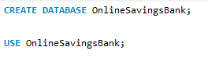

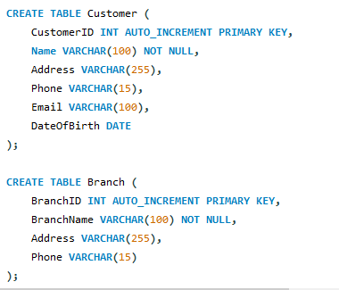

These are the first two tables created by the data definition language command CREATE TABLE and in these tables, all the attributes are needed to store information of the branch and customer. Include customer ID, branch ID, customer name, branch name, address of both customer and branch and last phone or can say contact information of both branch and customer.

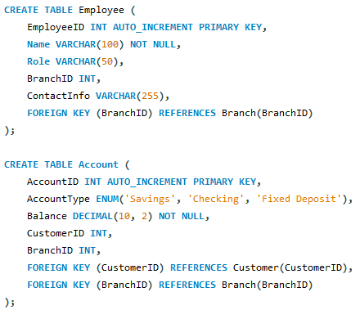

These are the next tables after customer and branch, these tables named are as employee and account and in these tables (*Elmasri, R., Navathe, ELT 2020*), there is all the information related to employees and accounts stored in these two tables.

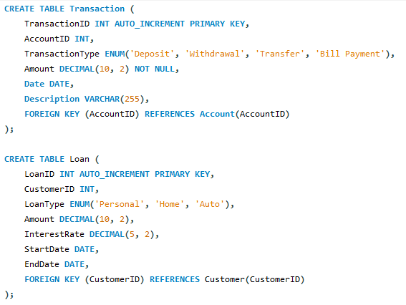

All the transactions or loan-related information stored in these tables include IDs of loan and transaction loan type, transaction type, etc.

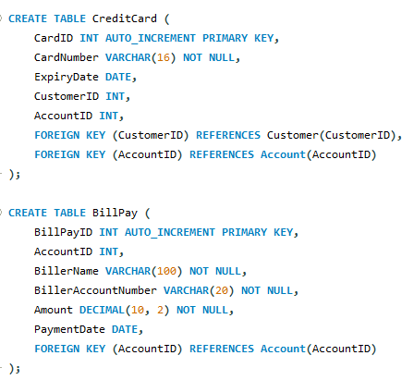

In these two tables, information related to credit cards and bill pay is stored here. Information includes credit card expiry date, and which customer owns a credit card their information is linked with the customer ID, and both tables are connected via a foreign key (*Zhang, D., Gao, F., ELT 2021*). In the biliary table information related billers are stored here.

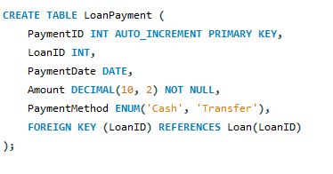

This is the last table of this database includes information related to loan payments.

All of these tables use DDL data definition language all of the databases are normalized and run as needed.

# Sophisticated DML statements:

In this section of the database development, there is include all the commands including insert, select, and multiple commands fall in this category.

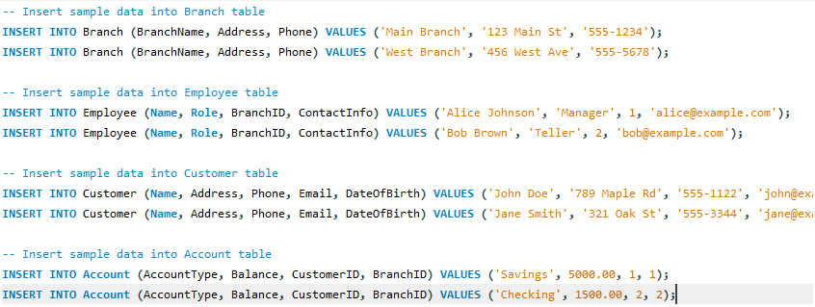

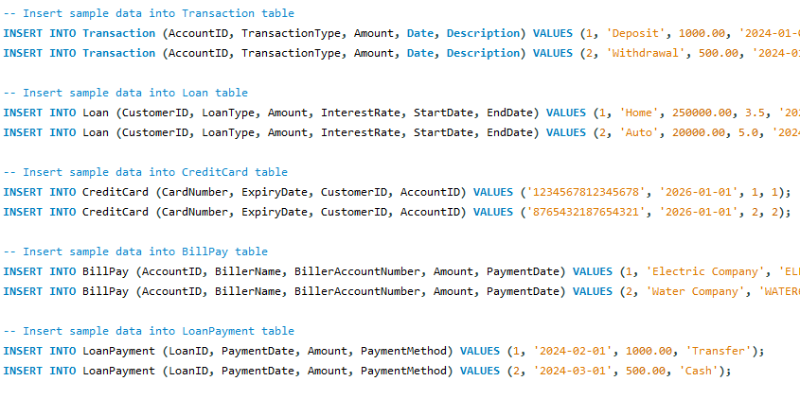

These are all the insert commands of the database which insert the data in each of the tables and at least 2 rows are added to each table.

#### Results:

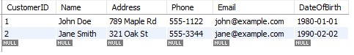

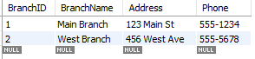

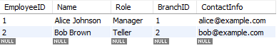

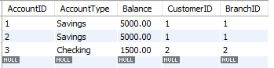

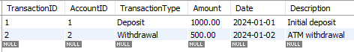

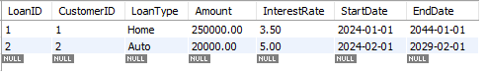

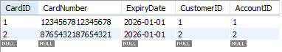

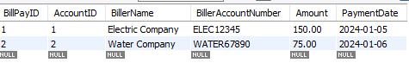



These are all the results related to each of the data insertions in the corresponding table.

## Queries:

***Fetch customer details along with their balance.***

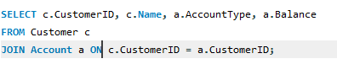

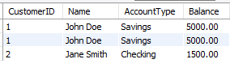

***Retrieve transaction details for an specific amount.***

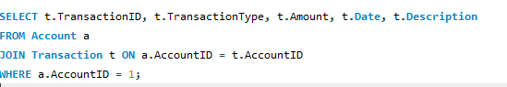



***List all employees working in a specific branch***

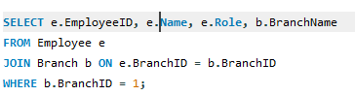



***Get loan details and their corresponding payment information.***

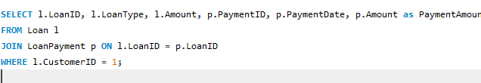



***Generate a summary report of total balances with the account type***

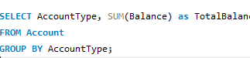



***Update the phone number of the specific customer***

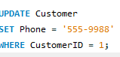



***Delete a record (remove transaction record)***





These are all the DML commands with their respective output this command includes the concept of select statement, join statement, delete, update, and where all the important components are implemented in this section.

# Conclusion:

In this report, there is defined all the important things which need to be discussed. First, there is a database topic which is a small saving bank database. The database consists of 9 tables including account, employee, customer, etc all of the tables have their attributes. Primary keys and foreign keys are used and maintain the normalization as well. Then in this report create an entity relation diagram whihc helps to understand the workflow of the database, after the entity relation diagram their is define some DDL data definition language commands including create database and create tables. After all this define and implement all the DML commands including joins, where clause, select, update, insert, and delete commands are implemented. This assessment gives good practice for using multiple database commands in a real-world scenario. This report is very beneficial for those who want to learn database management systems and want to build a database.

# References:

Ogli, R.A.R., 2022, February. The difference between the concepts of database and database management systems. In *Archive of Conferences* (pp. 33-34).

Azzahra, Z.F. and Anggoro, A.D., 2022. Analisis Teknik Entity-Relationship Diagram dalam Perancangan Database Sebuah Literature Review. *INTECH (Informatika dan Teknologi)*, *3*(1), pp.8-11.

Chen, I.M.A., Chu, K., Palaniappan, K., Ratner, A., Huang, J., Huntemann, M., Hajek, P., Ritter, S., Varghese, N., Seshadri, R. and Roux, S., 2021. The IMG/M data management and analysis system v. 6.0: new tools and advanced capabilities. *Nucleic acids research*, *49*(D1), pp.D751-D763.

Zhang, D., Gao, F., Jakovlić, I., Zou, H., Zhang, J., Li, W.X. and Wang, G.T., 2020. PhyloSuite: An integrated and scalable desktop platform for streamlined molecular sequence data management and evolutionary phylogenetics studies. *Molecular ecology resources*, *20*(1), pp.348-355.

Elmasri, R., Navathe, S.B., Elmasri, R. and Navathe, S.B., 2020, August. Fundamentals of Database Systems</Title. In *Advances in Databases and Information Systems: 24th European Conference, ADBIS 2020, Lyon, France, August 25–27, 2020, Proceedings* (Vol. 12245, p. 139). Springer Nature.